**Exercise 01**

Create the following Registration Form and and display the values of the input fields as shown below using HTML, CSS & PHP.

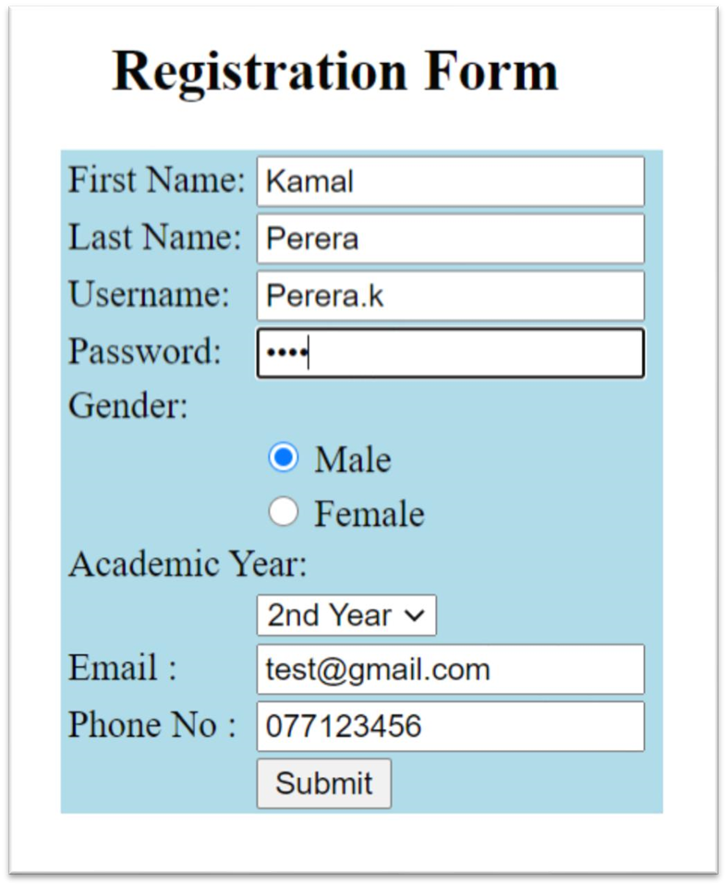

Once the submit button of the Registration form is clicked, the output should display like this.

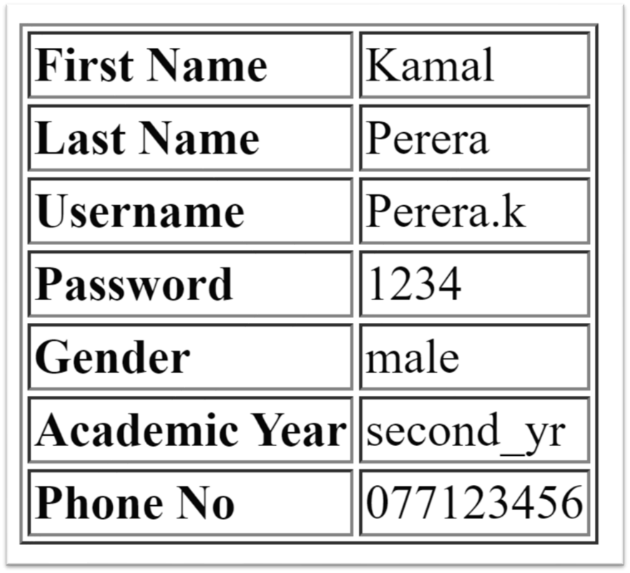

**html**

<html>

<head>

<title> Registration Form </title>

<style>

h2 {

text-align: center;

}

body {

font-family: Arial, sans-serif;

border: 2px solid black;

padding: 10px;

margin-top: 50px;

margin-left: 50px;

margin-right: 980px;

margin-bottom: 550px;

}

label {

display: block;

margin-bottom: 5px;

}

input {

margin-bottom: 15px;

}

table {

border-collapse: collapse;

margin-top: 20px;

}

th, td {

border: 1px solid #ddd;

padding: 8px;

}

</style>

</head>

<body>

<h2> Registration Form </h2>

<form action="phpprocess01.php" method="post">

<label for="firstname"> First Name: </label>

<input type="text" id="firstname" name="firstname">

<label for="lastname"> Last Name: </label>

<input type="text" id="lastname" name="lastname">

<label for="username"> Username: </label>

<input type="text" id="username" name="username">

<label for="password"> Password: </label>

<input type="password" id="password" name="password">

<label for="gender"> Gender: </label>

<input type="radio" id="gender" name="gender" value="Male"> Male

<input type="radio" id="gender" name="gender" value="Female"> Female

<label for="academicYear"> Academic Year: </label>

<select id="academicYear" name="academicYear">

<option value="Year"> Year </option>

<option value="1st Year"> 1st Year </option>

<option value="2nd Year"> 2nd Year </option>

<option value="3rd Year"> 3rd Year </option>

</select> <br> <br>

<label for="email"> Email: </label>

<input type="email" id="email" name="email">

<label for="phoneNo"> Phone No: </label>

<input type="tel" id="phoneNo" name="phoneNo">

<br> <input type="submit" value="Submit">

</form>

</body>

</html>

**php**

<html>

<head>

<title>Registration Data</title>

<style>

body {

font-family: Arial, sans-serif;

margin: 20px;

}

table {

border-collapse: collapse;

}

th, td {

border: 1px solid #ddd;

padding: 8px;

}

</style>

</head>

<body>

<h2>Registration Data</h2>

<?php

if ($_SERVER["REQUEST_METHOD"] === "POST")

{

$firstname = $_POST["firstname"];

$lastname = $_POST["lastname"];

$username = $_POST["username"];

$password = $_POST["password"];

$gender = $_POST["gender"];

$academicYear = $_POST["academicYear"];

$email = $_POST["email"];

$phoneNo = $_POST["phoneNo"];

}

?>

<table>

<tr>

<th> First Name </th>

<td> <?php echo $firstname; ?> </td>";

</tr>

<tr>

<th> Last Name </th>

<td> <?php echo $lastname; ?> </td>";

</tr>

<tr>

<th> Username </th>

<td> <?php echo $username; ?> </td>";

</tr>

<tr>

<th> Password </th>

<td> <?php echo $password; ?> </td>";

</tr>

<tr>

<th> Gender </th>

<td> <?php echo $gender; ?> </td>";

</tr>

<tr>

<th> Academic Year </th>

<td> <?php echo $academicYear; ?> </td>";

</tr>

<tr>

<th> Email </th>

<td> <?php echo $email; ?> </td>";

</tr>

<tr>

<th> Phone No </th>

<td> <?php echo $phoneNo; ?> </td>";

</tr>

</table>

</body>

</html>